**EMS Workflow Manager**

### A PROJECT REPORT

***Submitted by***

## Harikrashna Nitinbhai Parikh

### 190320132031

***In partial fulfillment for the award of the degree of***

## BACHELOR OF ENGINEERING

***In***

**Information and Communication Technology**

**L. J. Institute of Engineering & Technology Ahmedabad**



## Gujarat Technological University, Ahmedabad

#### April, 2023

 

## L. J. Institute of Engineering & Technology

**Ahmedabad**

# CERTIFICATE

This is to certify that the project report submitted along with the project entitled **Argusoft - Employee Workflow Manager** has been carried out by **Harikrashna Nitinbhai Parikh** under my guidance in partial fulfillment for the degree of Bachelor of Engineering in **Information and Communication Technology**, 8th Semester of Gujarat Technological University, Ahmadabad during the academic year 2022-23.

Prof. Shweta Shah Prof. Prayag Patel

#### Internal Guide Head of the Department

 

**L. J. Institute of Engineering & Technology**

**Ahmedabad**

# DECLARATION

We hereby declare that the Internship report submitted along with the Internship entitled **EMS Workflow Manager** submitted in partial fulfillment for the degree of Bachelor of Engineering in **Information and Communication Technology** to Gujarat Technological University, Ahmedabad, is a bonafide record of original project work carried out by me at Argusoft India Ltd. under the supervision of Mr. Braj Dangi and that no part of this report has been directly copied from any students’ reports or taken from any other source, without providing due reference.

|  |  |
| --- | --- |
| Name of the Student | Sign of Student |
| Harikrashna Nitinbhai Parikh |  |

## ACKNOWLEDGEMENT

I wish to express my sincere gratitude to our external guide **Mr. Braj Dangi** and the HR team for continuously guiding me at the company, answering all my doubts with patience and providing me with all the necessary help, information and resources.

Also, I want to thank my internal guide **Prof. Shweta Shah** and the department for their timely clarification, help, cooperation and important support. With the help of all these people this I was able to perform good in internship.

In addition, I would like to acknowledge the contribution of my colleagues and team members, who provided a supportive and collaborative environment that encouraged my growth and development. Finally, I would like to thank **Argusoft India Pvt Ltd**. for providing opportunities and resources that allowed me to explore different aspects of the industry and gain a deeper understanding of its challenges and opportunities.

**Abstract**

*This report is about my internship at* ***Argusoft India Ltd****. It was a Web Application Development project on company’s web portal or Employee Management System. In which our team was assigned the task of creating a feature to log details of daily work done by an employee in the system, and the data can later be used to feedback the employee accordingly. During my internship I learned a lot of things like various practices and coding conventions for web development in the industry, learned to solve problems, errors and bugs, to understand problem statement and make flow of code accordingly, to submit work within deadlines, experienced working in a team which include solving problems together distributing work, and communicating with each other. These skills have helped me become industry ready.*

**List of Figures**

Fig 2.1 Software Production Process 3

Fig 3.1 Angular Logo 6

Fig 3.2 Spring Boot Logo 6

Fig 3.3 Java Logo 6

Fig 3.4 PostgreSQL Logo 7

Fig 3.5 Internship Gantt Chart 7

Fig 4.1 Visual Studio Code Logo 10

Fig 4.2 IntelliJ Logo 10

Fig 4.3 Pg Admin Logo 10

Fig 5.1 Use Case Diagram 11

Fig 5.2 Activity Diagram 13

Fig 6.1 Status calendar Module Screen 14

Fig 6.2 List of feedbacks datewise 15

Fig 6.3 Add Work Status 15

Fig 6.4 Edit Work Status 16

Fig 6.5 Remarks from Mentor 16

Fig 6.6 Final Remarks from mentors 17

## List of Tables

Table 5.1 Work Log Table 12

**List of Abbreviations**

|  |  |
| --- | --- |
| SOA | Service Oriented Architecture |
| mODC | Managed Offshore Development Center |
| BA | Business Analysis |
| UI | User Interface |
| UX | User Experience |
| QA | Quality Assurance |
| IT | Information and Technology |
| CRUD | Create Read Update Delete |
| CRM | Customer Relationship Manager |
| JDK | Java Development Kit |
| XML | Extensible Markup Language |
| IDE | Integrated Development Environment |

**Table of Contents**

Declaration i

Acknowledgement ii

Abstract iii

List of Figures iv

List of Tables vi

List of Abbreviations vii

Table of Contents viii

Chapter 1 Overview of the Company 1

* 1. History 1
  2. Different product / scope of work 1

Chapter 2 Overview of different department and production/process being carried out in company 3

Chapter 3 Introduction to Internship and Internship Management 4

* 1. Internship Summary 4
  2. Purpose 4
  3. Objective 5
  4. Scope 5
  5. Technology Used 5
  6. Internship Scheduling 7

Chapter 4 System Analysis 8

* 1. Study of Current System 8
  2. Problem and Weaknesses of Current System 8
  3. Requirements of New System 8
  4. System Feasibility 8
  5. Activity in New System 9
  6. List Main Components of New System 9
  7. Selection of Software 9

Chapter 5 System Design 11

* 1. System Design & Methodology 11
  2. Database Design 12
  3. Input / Output and Interface Design 13

Chapter 6 Implementation 14

* 1. Outcomes 14
  2. Result Analysis 19

Chapter 7 Testing 20

Chapter 8 Conclusion and Discussion 21

* 1. Overall Analysis of Internship Viabilities 21
  2. Dates of Continuous Evaluation (CE-I and CE-II) 21
  3. Problem Encountered and Possible Solutions 21
  4. Summary of Internship work 22
  5. Limitation and Future Enhancement 23

## OVERVIEW OF THE COMPANY

### HISTORY

Argusoft started back in 2000 as a services company, engaged in providing intensive hands-on training to produce enhanced Peoplesoft professionals from India. In the early days, the company followed an onsite-offshore model, where it worked with an American company Intelliant to provide these resources for placement in projects in the US. Soon thereafter Argusoft migrated to provide more value-add through offshore IT engineering services as that was the emerging paradigm shift at that time.

### DIFFERENT PRODUCT / SCOPE OF WORK

They augment client teams with their software development, testing, maintenance and support. Their primary focus is Business Automation and SOA system integration, leveraging Java, PHP, dot Net and Web 2.0 related technologies. We deliver these services as turnkey projects or through our extended team model (mODC - managed Offshore Development Center), providing a completely managed team, to ensure continuity and efficiency. Following are the services provided by the company: -

#### mODC

Managed Offshore Development Center model, provides a managed team of developers, as an extension of client teams, with access to peripheral resources like BA, UI/UX, QA as needed

#### Turnkey Solutions

Providing end to end IT software system integration solutions to their customers based on their custom requirements, using the latest tools and technologies - Define-Develop- Deploy-Support

#### Third Party QA

Dedicated team to ensure an objective testing of client software system to enable a faster, more confident launch.

#### Mobile Development

Keeping pace with the latest in mobile technologies, they develop enterprise- grade cross-platform mobile applications.

* **DevOps Consulting Services**

Helping client to build a DevOps environment from scratch and redefine your delivery & deployment strategy through our services.

## OVERVIEW OF DIFFERENT DEPARTMENT AND PRODUCTION/PROCESS BEING CARRIED OUT IN COMPANY.

The following image shows the production process that is followed by the company to develop a software product.

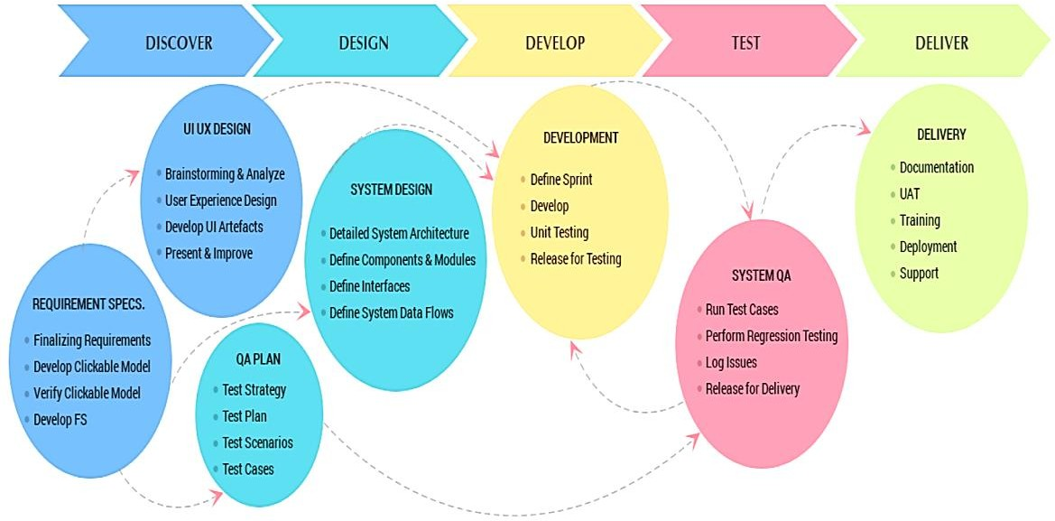

Fig 2.1 Software Production Process

**2.2 TECHNICAL SPECIFICATIONS OF MAJOR EQUIPMENT USED IN EACH DEPARTMENT**

Mostly all employees use the company’s provided personal system.

Operating System: Windows 10 / Ubuntu 20.04.4 LTS

Processor: Intel core i3 11th generation

RAM: 16 GB

Disk Capacity: 256 GB SSD

Graphics: Intel HD 630 – 8 GB

## Introduction to Internship and Internship Management

### INTERNSHIP SUMMARY

The main aim of the internship was to make students industry ready, I achieved the same during my internship. My internship started with the learning stage, where I learned various programming languages and technologies or enhanced my skills in the previously learned programming languages and technologies like Java, Angular, Spring Boot, MySQL and PostgreSQL. After that I developed a demo application using the above- mentioned technologies. It was a basic CRUD (Create Read Update Delete) system for details of employees in a company for example entering new employee data to database, updating data of given employee deleting data of employee or employees and viewing data of employees. When the demo application was approved by the mentor, My mentor assigned Our Team live project of Employee Management System where I had to develop a feature “EMS Workflow Manager” in that Employee’s Attendance Log & Details and Feedback Section where to enter status of work done by them and by using that mentor can give them feedback.

### PURPOSE

The main purpose of the internship is: -

* To become industry ready.
* To be able to learn skills and adapt technologies quickly.
* To be able to understand flow of given problem efficiently and prepare action plan to solve it.
* To be able to complete given tasks within given deadline.
* To be able to work with team members which include efficient distribution of work and good communication.
* To understand the ethics of an employee as a developer which include maintaining privacy and security client’s data.

### OBJECTIVE

Following are the objectives of my internship: -

* I surfed through various resources on internet like websites, video tutorials, blogs, documentations, and sample applications to gain the required skills for technologies and programming to be able to complete all tasks during the internship.
* I made necessary presentations, flowcharts, to understand problem statement and generate a flow of code.
* I worked with team members, communicated with each other exchanged ideas and accepted their thoughts, distributed work (tasks) among ourselves.
* I did various testing, debugging, and validation work for a safe, secure and efficient code.

### SCOPE

The **Workflow Manager** feature in the Employee Management System enables an employee to log In/Out Attendance. The Attendance will store in the Database and also showed in Attendance Details Section by Chart Visualization. The worklog data is validated by a manager under which the employees are working. Also Employee can add Feedback on daily basis and Particular Mentor can Approve them on basis of performance.

### TECHNOLOGY USED

* **Frontend**: For developing the frontend of the website we used **Angular** (version 6) The advantages of angular include effective cross-platform development, high quality of the application, improved speed and performance, faster development process. Figure 3.1 shows logo of Angular.



Fig 3.1 Angular Logo

* **Backend**: For developing the backend of the website we used **Spring Boot** which is a framework of **Java** (JDK 8). The advantages of Spring Boot include fast and easy development of spring-based applications, the ability to create standalone applications, helping to directly embed Tomcat, Jetty, or Undertow into an application, no need for XML configuration, reduced amounts of source code. Figure 3.2 shows of logo of Spring Boot Framework and Java.



Fig 3.2 Spring Boot Logo



Fig 3.3 Java Logo

* **Database**: We used **PostgreSQL** as the database for storing data. The advantages of using PostgreSQL are Open-Source DBMS, diverse community, ACID and transaction, diverse indexing techniques, flexible full-text search.



Fig 3.4 PostgreSQL Logo

### INTERNSHIP SCHEDULING (GANTT CHART)

The following figure shows the Gantt Chart of the internship completed by me in 12 weeks.

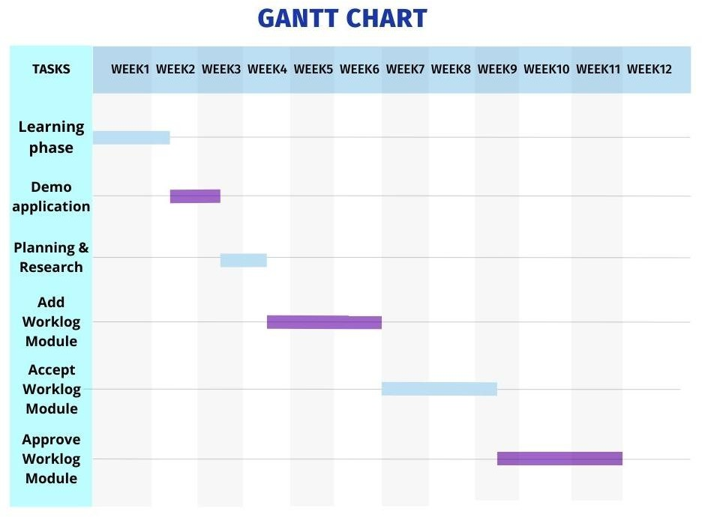

Fig 3.5 Internship Gantt Chart

## SYSTEM ANALYSIS

### STUDY OF CURRENT SYSTEM

In the current system the We uses an excel document/Google Spread Sheet with the names of employees as rows and days of month and total work hours as columns. In this document the extra work data is edited by the employee. This document is made monthly which contains the total work of every employee for that project in the given month. For Feedback and daily work log details there is also used Excel and Google Docs. There were no measurements for total hours or statistics to analyze.

### PROBLEM AND WEAKNESSES OF CURRENT SYSTEM

The problem of the current system is that an employee has to edit the excel document to log the extra work hour which is a difficult task itself. Also, the document is only finally verified by CRM which takes a lot of time from a human perspective.

### REQUIREMENTS OF NEW SYSTEM

The new system will introduce a better way to log extra work using the User Interface (UI). Employee can log more details of extra work like description. New system is required to reduce the insertion of erroneous data. Also in this new system, manager would be able to verify whether the employee’s claim forwork is true only after that the work log would be approved by CRM to ensure trustworthiness of data. This will enable better display of data and necessary statistics.

### SYSTEM FEASIBILITY

The system can be implemented using the current technology and within the given cost and schedule constraints as it is an additional feature in the company’s website and can be easily integrated with other systems (or features) which are already in website. The new system i.e., the work log feature fulfills the objectives of organization to log daily attendance of work by employee, acceptance by manager, approval by CRM, and charging client according to data, better UI and flow and understandable process.

### ACTIVITY IN NEW SYSTEM

An employee can get all the information regarding work log/Attendance in the attendance section of the UI of website. Firstly, for an employee he/she can do In/Out by clicking In/Out button on Home Page.

After a day the daily data of in/out will be shown at home page by Chart. Also an employee can see more details of attendance by clicking on Attendance Report. Also Employee can see the attendance details by filtering particular time periods.

Feedback Section, In that employee can add/write work log on daily basis. The Mentor/Lead can give feedback or can give Red flag on their performance. Also can see all feedback by clicking on Feedback Report.

### LIST MAIN COMPONENTS OF NEW SYSTEM

Following are the main components in the Attendance and Feedback feature.

* Log In/Out
* Add Daily work status
* List all feedbacks
* List all status-logs of mentee under a mentor
* Give remarks to mentee by mentor.
* List all Attendance Report

### SELECTION OF SOFTWARE

Following are the software used by our team to develop the work log feature:

* To edit the code of frontend i.e., Angular, text editor used is **Visual Studio Code**.



Fig 4.1 Visual Studio Code Logo

* To edit, compile, debug and run code of backend i.e., Spring Boot and Java, Integrated Development Environment (IDE) used is **IntelliJ**.



Fig 4.2 IntelliJ Logo

* To run queries, view data, schema, tables of database i.e., PostgreSQL, tool used is **pgAdmin 4**.



Fig 4.3 Pg Admin Log

1. **SYSTEM DESIGN**

### 5.1 SYSTEM DESIGN & METHODOLOGY

The figure 5.1 shows the Use Case diagram of the work-log system / feature.

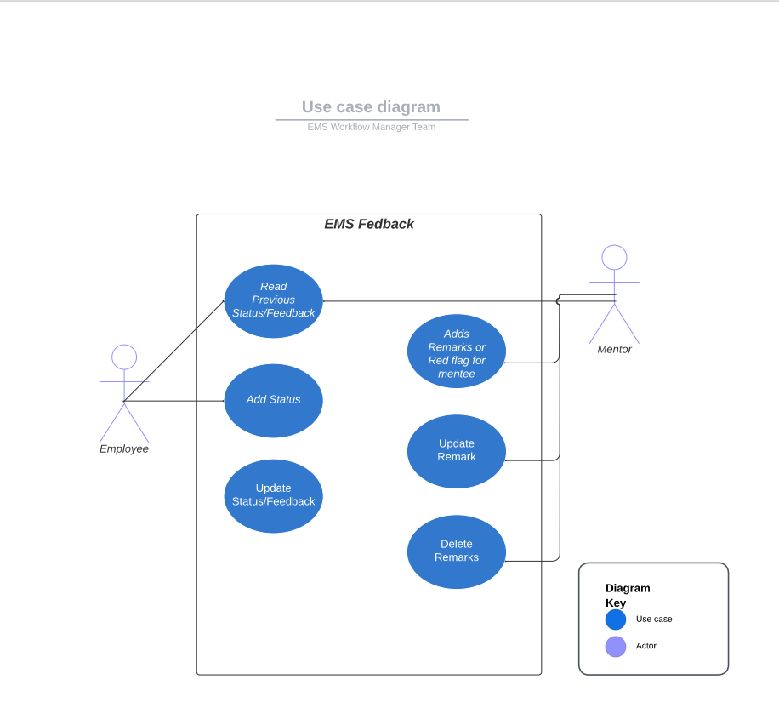

Fig 5.1 Use Case Diagrem

**5.2 DATABASE DESIGN**

The table 5.1 shows the design / schema of the database table for data of feedback work of an employee.

Table 5.1 Feedback Database Design Table

|  |  |  |  |  |
| --- | --- | --- | --- | --- |
| **Sr. No.** | **Field** | **Data Type** | **Constraint** | **Example** |
| 1. | feedback_id | BIGINT | PRIMARY KEY | 344 |
| 2. | feedback_date | TIMESTAMP | NOT NULL | 10-04-2022 |
| 3. | approval_date | TIMESTAMP | Default current time | 10-04-2022 |
| 4. | status | VARCHAR |  | JAVA |
| 5. | obstacle | VARCHAR |  | Good work |
| 6. | mentor_id | INT | NOT NULL | 123 |
| 7. | employee_id | INT | NOT NULL | 126 |
| 8. | Red_flag | TINYINT |  | 0 OR 1 |
| 9. | session_name | VARCHAR |  | Project-2 |
| 10. | remarks | VARCHAR |  | Good work |

The table 5.2 shows the design / schema of the database table for data of Attendance log In/Out Time of an employee.

Table 5.2 Attendance Database Design Table

|  |  |  |  |  |
| --- | --- | --- | --- | --- |
| **Sr. No.** | **Field** | **Data Type** | **Constraint** | **Example** |
| 1. | In_out_id | BIGINT | PRIMARY KEY | 344 |
| 2. | employee_id | INT | NOT NULL, FK | 123 |
| 3. | created_at | TIMESTAMP | Default current time | 10-04-2022 9.45 am |
| 4. | created_by | VARCHAR | Default ‘Admin’ | ‘Admin’ |
| 5. | updated_at | TIMESTAMP | Default current time | Good work |
| 6. | updated_by | VARCHAR | Default ‘Admin’ | 123 |

## IMPLEMENTATION

**6.1 OUTCOME**

The following figures (screen shot of website) shows the outcome of my internship i.e., the feature made in the company’s website.

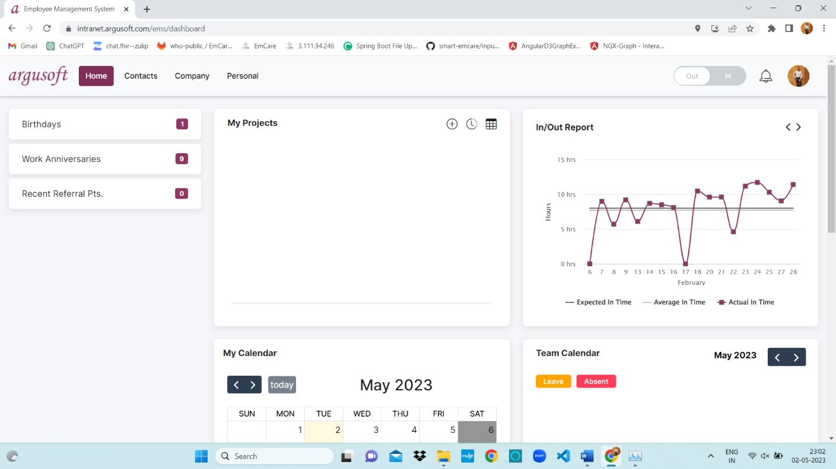

Fig 6.1 EMS Home Page In/Out and It’s Chart Visualization

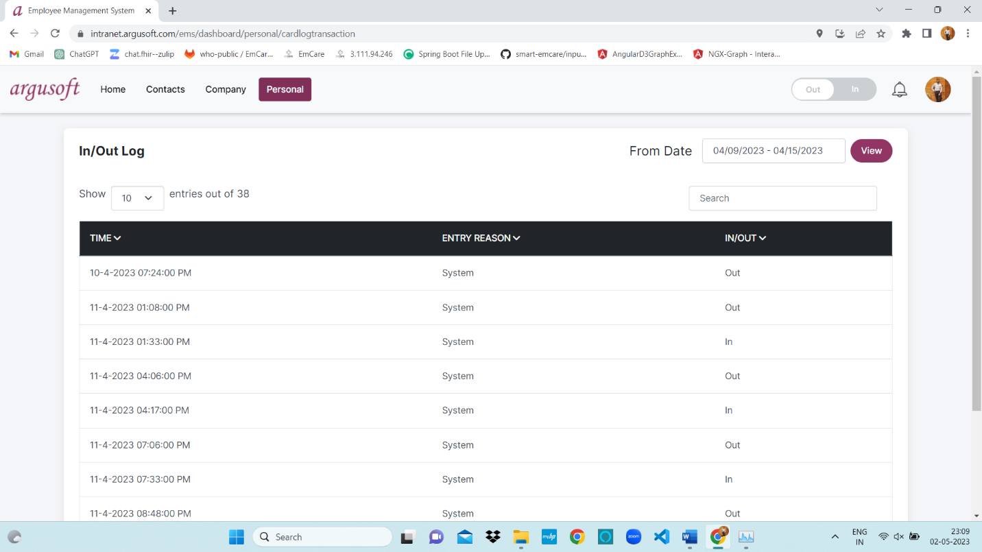

Fig 6.2 Attendance In/Out Log

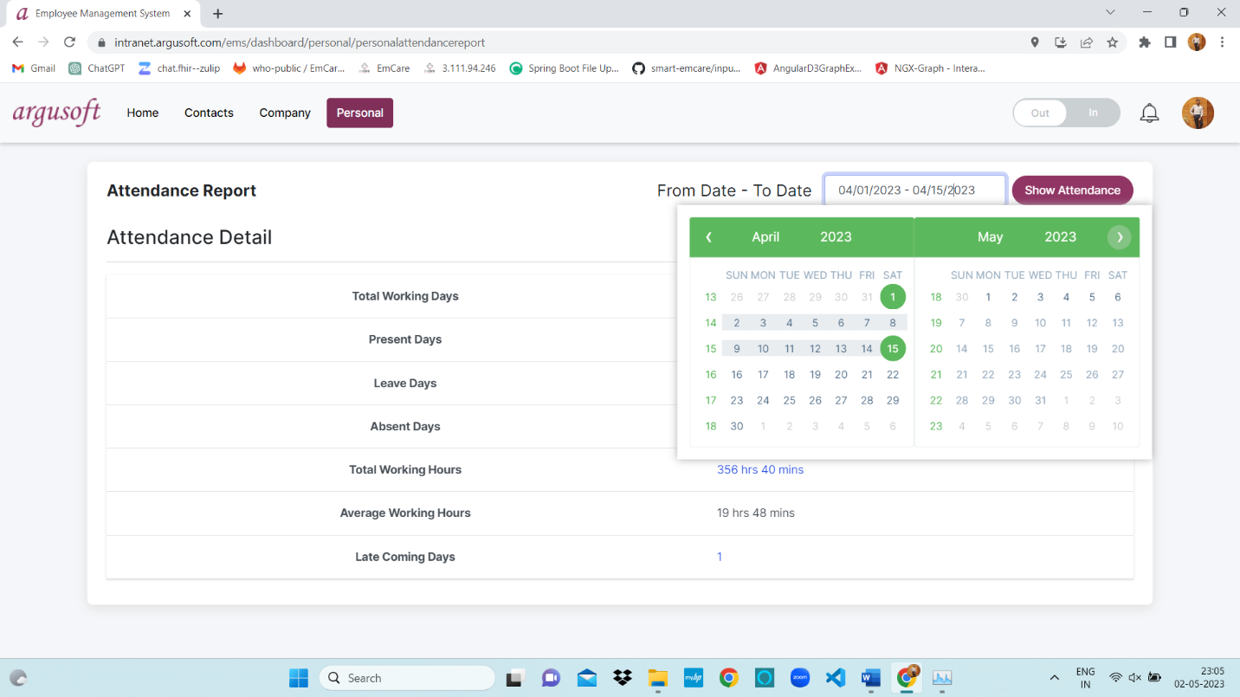

Fig 6.3 Attendance Report for Time Period

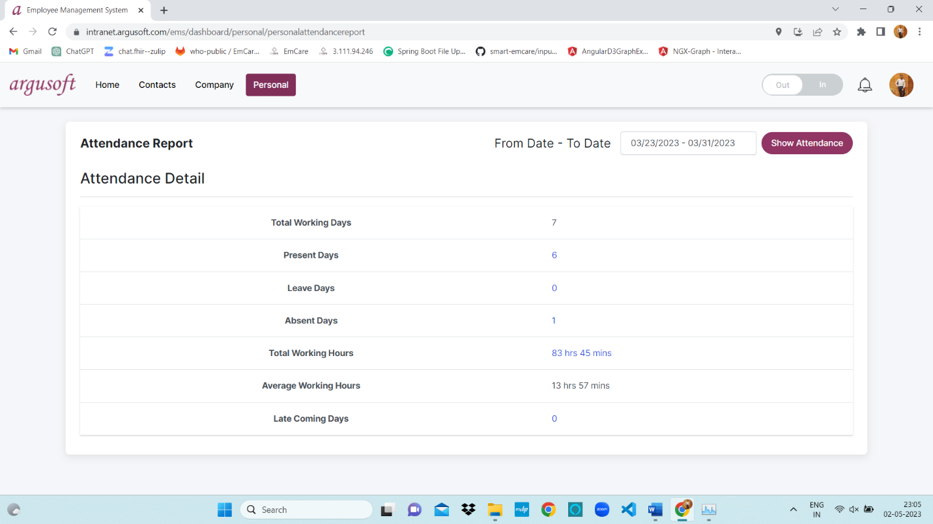

Fig 6.4 Attendance Report

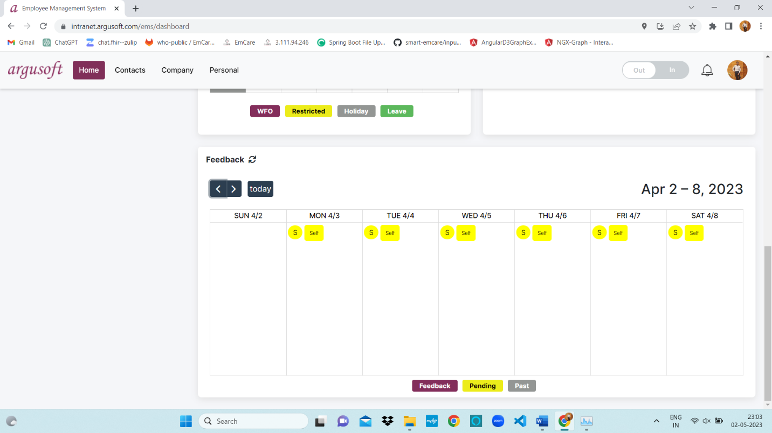

Fig Fig 6.5 Feedback Section Pending Status

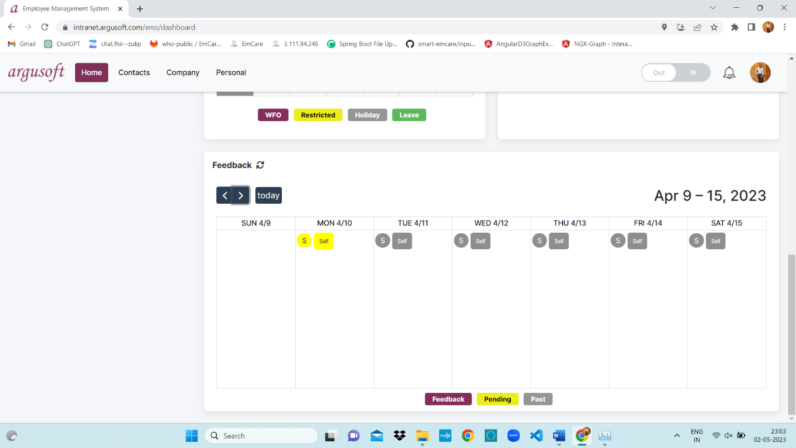The figure 6.

Fig 6.6 Feedback Section Past Status

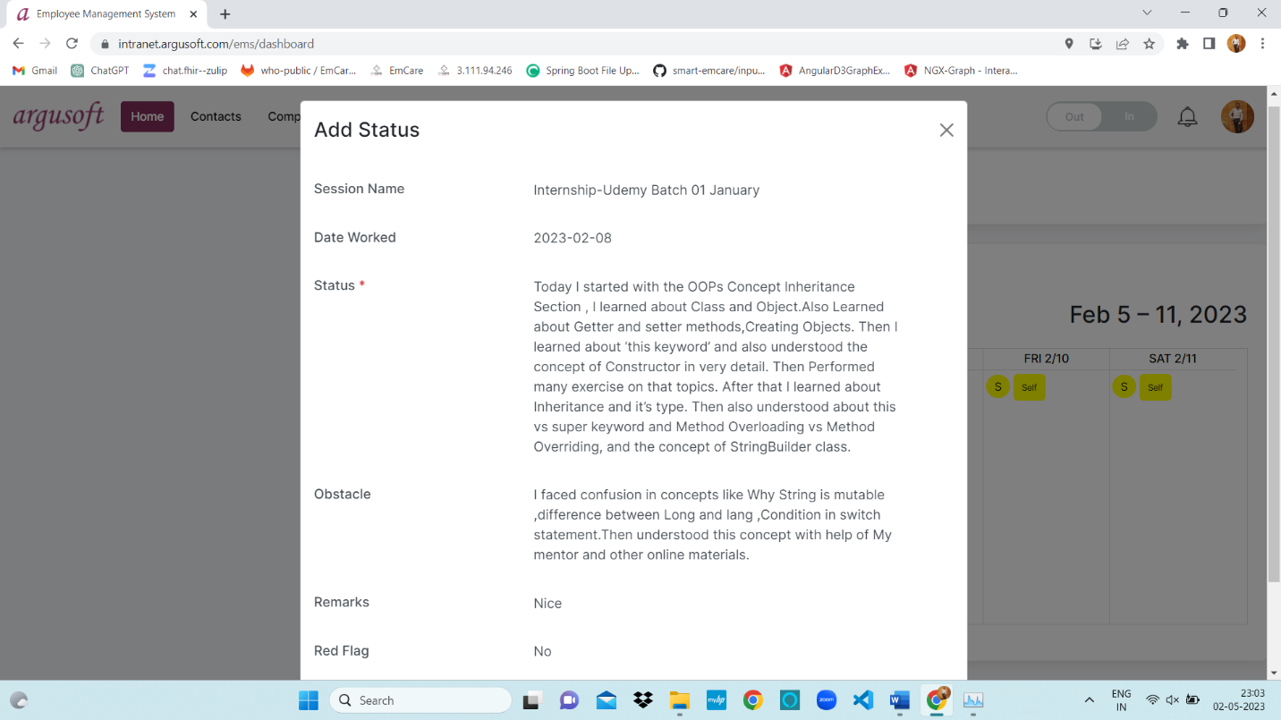

05-04-2023

Fig 6.7 Mentor gives Remark / Red Flag

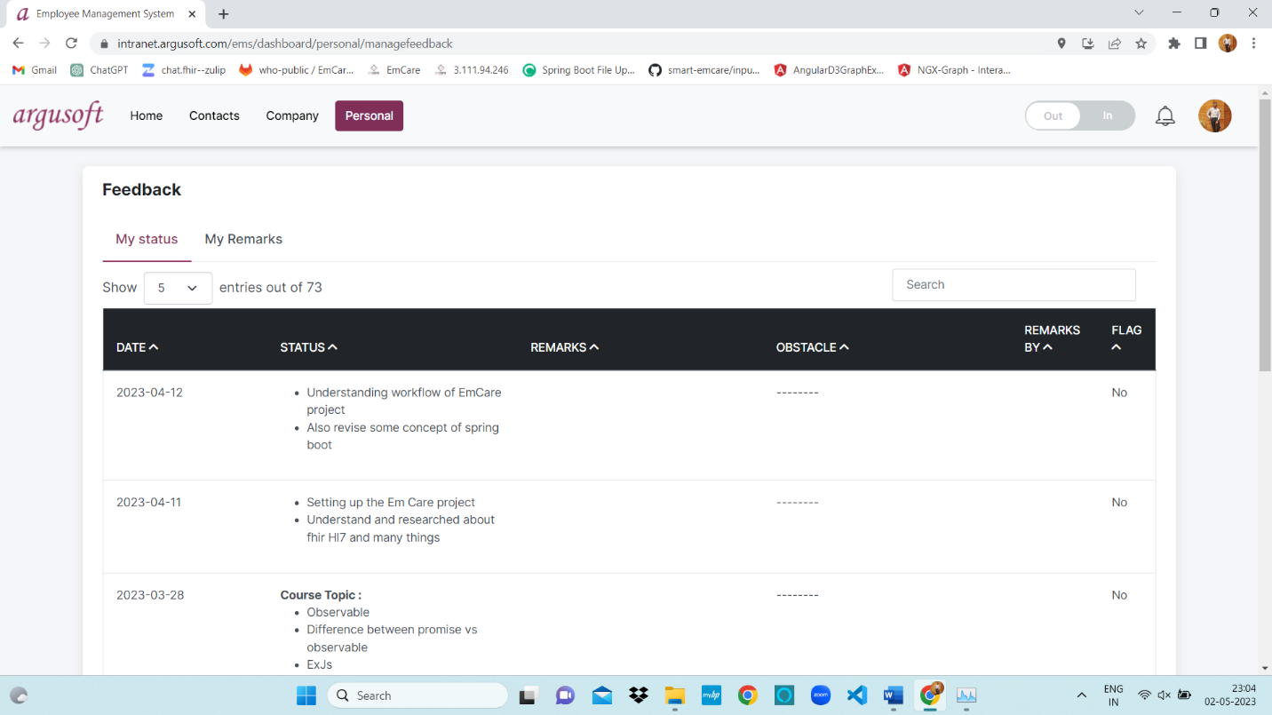

Fig 6.8 All Past Feedback Section

### 6.2 RESULT ANALYSIS

The new feature designed for Attendance log and Feedback section by trainee is better than the old method of editing and filling the excel document. As the new system does the following: -

* Reduced probability of entering wrong date in excel sheets.
* Detailed data of work can be stored.
* Extra verification can be done by manager.
* No need to check data manually.
* A good UI available, easy to understand process of adding work log.

## 7.1 TESTING

A few test cases were written for the demo project which includes: -

* Test which verifies if employee data is getting stored.
* Test which verifies if employee data is updated.
* Test which verifies if all employee data can be read.
* Test which verifies if particular employee data can be deleted.
* Test which verifies if all employee data can be deleted.

And for the Employee Management System validations code was written for: -

* Form validations of add status for trainee.
* Manage status button only available to a mentor.
* Remarks status feature only available to a manager.
* Give Red Flags to mentee.
* Validation for only the needed limited data to be transferred from backend to frontend.

## 8. CONCLUSION AND DISCUSSION

### OVERALL ANALYSIS OF INTERNSHIP

Throughout the internship I learned a lot of things. I got knowledge about how Information and Technology (IT) industry works, about the projects of clients, working with a team under guide’s supervision, communicating with team members, submitting work within deadline, solving problems in real time, finding answer to errors on internet websites such as stack overflow. I attended meetings, discussed on various subjects like form designs flow of process and learned to present my views to others.

### DATES OF CONTINUOUS EVALUATION (CE-I AND CE-II)

**CE-I: 27/02/2023 CE-II: 24/04/2023**

### 8.3 PROBLEM ENCOUNTERED AND POSSIBLE SOLUTIONS

Here are few of the problems that I encountered and their solutions I found during my internship: -

* The first problem was learning many new technologies from scratch like Angular, Spring boot etc.

### Another challenge was to understand and maintain the complex code structure of the project.

### My mentor helped me break down the modules so that I could understand them easily.

### Another problem I identified was to transfer complex data back from the backend to frontend.

### To simplify and transfer to the front-end, I used a map and list data structure.

### 8.4 SUMMARY OF INTERNSHIP

This internship was a good phase to learn about the industry and real-world applications in it, I achieved the same during my internship. My internship started with the learning stage, where I learned various programming languages and technologies like Java, Angular, Spring Boot and MySQL. After that I developed a demo application using the above-mentioned technologies. Our team has been assigned the project name EMS Workflow Manger in that I was assigned to develop Attendance Work Log and Feedback Section. I learned to work with team, work under guide, complete and submit my work before given deadline, to communicate with team, understand concepts, deliver my ideas to team etc.

**8.5 FUTURE ENHANCEMENT**

For the future enhancement there is a need to introduce a feature to download the pdf file of statistics containing data of attendance log and Feedback past details of particular time period under a project so that the pdf document file can be directly sent to manager and manager can see progress of Attendance details of Employees.

**REFERENCES**

* [**https://www.argusoft.com/**](https://www.argusoft.com/)
* [**https://docs.oracle.com/en/java/**](https://docs.oracle.com/en/java/)
* [**https://angular.io/docs**](https://angular.io/docs)
* [**https://docs.spring.io/spring-boot/docs/current/reference/htmlsingle/#documentation**](https://docs.spring.io/spring-boot/docs/current/reference/htmlsingle/#documentation)
* <https://en.wikipedia.org/wiki/Visual_Studio_Code>
* <https://www.postman.com/>
* <https://www.w3schools.com/bootstrap/>